DAY 2 28-12-2016

K-Means

**1.**

**import** **pandas** **as** **pd**

**from** **sklearn.cluster** **import** KMeans

2.

kmeans_data1 = pd.read_csv('K_meansHW_TomMitchell_data1.csv',sep = ",",header=None,names=['x','y'])

3.

kmeans_data1.head()

4.

%**matplotlib** inline

5.

**import** **matplotlib** **as** **plt**

6.  
plt.pyplot.scatter(kmeans_data1['x'],kmeans_data1['y'])

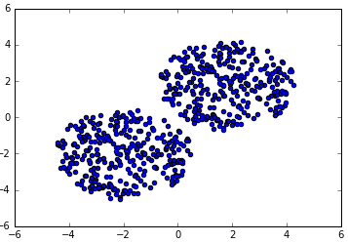

7.

kmeans_result = KMeans(n_clusters = 2,random_state=0).fit(kmeans_data1)

8.

kmeans_result.labels_

9.  
kmeans_result

10.

plt.pyplot.scatter(kmeans['x'],kmeans['y'],c=kmeans_result.labels_)

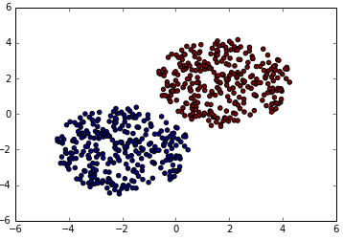

11.

kmeans_data2 = pd.read_csv('K_meansHW_TomMitchell_data2.csv',sep = ",",header=None,names=['x','y'])

12.  
kmeans_data2.head()

13.

plt.pyplot.scatter(kmeans_data2['x'],kmeans_data2['y'])

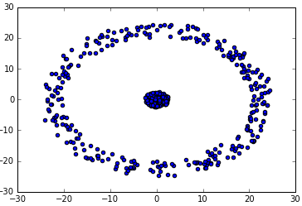

14.

kmeans_result2 = KMeans(n_clusters = 4,random_state=0).fit(kmeans_data2)

15.

kmeans_result2.labels_

16.

plt.pyplot.scatter(kmeans_data2['x'],kmeans_data2['y'],c=kmeans_result2.labels_)

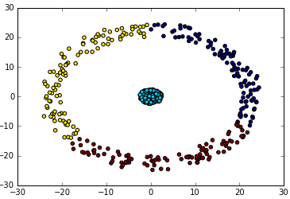

----------------------------------------------------------------------------------------------------------------------

Regression

-----------------------------------------

**1.**

**import** **pandas** **as** **pd**

**import** **matplotlib.pyplot** **as** **plt**

2.

train_df = pd.read_csv('girls_train.csv',header = None, names=['Age','Height'])

3.

train_df.head()

4.  
%**matplotlib** inline

5.

plt.scatter(train_df['Age'],train_df['Height'])

6.

train_df['intercept'] = 1

7.

train_df.head()